

2023-24

CMSE11427 Web and Social Network Analytics

Individual coursework

Optimising Digital Strategies: Insights from Web and Social Analytics

B244512

Word count:

1302

# **Optimising Digital Strategies: Insights from Web and Social Analytics**

## Introduction

This report explores the utility of web traffic and social network analysis across three sections—two theoretical and one practical—to offer strategic insights for businesses including UnicornJobs, RunTartan, and HaggisBus.

## **Feasibility Analysis on Applying Recommender Systems to UnicornJobs’ Dataset**

Recommender systems are systems that aim to predict the preferences of users based on previous searches or purchases of previous users.

### How Recommender Systems Work

Recommender systems collect and analyze user behaviour, preferences, and activity data from sources like ratings and browsing history. They profile items and users with characteristic features, then recommend similar items to users with matching profiles using measures like Jaccard Similarity.

### Using Recommender Systems in HR for Matching Candidates and Jobs

Two approaches are used: Collaborative Filtering, recommending jobs based on similar user behaviours and preferences without needing extra user or item info, and Content-Based Recommendation, a supervised method that uses user features (e.g., resume details, work experience) and job characteristics (e.g., descriptions) to suggest matching jobs, analysing user ratings and personal traits to align with new users' profiles and preferences.

### Possible benefits

#### Boosting Recruitment Efficiency

The vast volume of data makes it possible to automatically match individuals with appropriate job positions based on their profiles and preferences, greatly speeding up the recruitment process.

#### Improved Candidate-Job Fit

These algorithms can find subtle connections between candidate talents and job needs by analysing large volumes of data, which raises retention and job satisfaction rates.

### Possible pitfalls

#### Over-Reliance on Historical Data

Systems using past hiring data may be biased towards candidates with standard career paths, reducing creativity and diversity.

#### Technical Complexity and High Costs

Developing, testing, and deploying a recommender system demands high-quality, comprehensive data and substantial initial investment, alongside ongoing maintenance and update costs.

### Ethical Concerns and Solutions

#### Diversity and Social Mobility

If poorly designed, recommender systems may prefer candidates similar to existing employees, limiting social mobility and disadvantaging those from underrepresented or economically challenged backgrounds, such as those from lower-tier universities. A solution is to make the system's criteria and decisions transparent, ensuring accountability.

#### Privacy Concerns

The vast data collection by these systems poses privacy and security risks. For instance, Udemans, C. (2019) reported a leak of 160,000 resumes from Zhilian Zhaopin by former employees, sparking widespread concern. To mitigate these risks, solutions like MD5 encryption or facial recognition could be employed for enhanced verification when accessing candidates' CVs.

## Strategic Analysis on Finding Lifestyle Influencers for RunTartan

Influencers can enhance your brand's advertising by encouraging potential customers to follow your social media. This analysis aims to identify suitable influencers for RunTartan, a sportswear company.

### Measuring Whether Someone Is a Good Influencer

Recommended approaches include degree, betweenness, and authority.

#### Degree

Degree, a centrality measure in graph theory, counts a node (a single unit in a graph)'s adjacent edges. Using it to gauge an influencer's impact suggests choosing those with many followers. However, this doesn't assure interest alignment, especially in niches like sportswear. For instance, a popular Korean male star may have numerous followers, primarily young women possibly disinterested in sports, offering less value for a sportswear brand than a fitness blogger whose audience, likely more engaged in exercise, could promise a higher conversion rate for sports clothing purchases.

#### Betweenness

Betweenness centrality measures how often a node appears on the shortest paths between pairs of nodes in a network. It's calculated by finding all shortest paths between each node pair and then determining the proportion of these paths that pass through a given node (V). However, this metric has limitations. For example, a BBC news account may have high betweenness due to its broad audience and diverse followers, but this doesn't imply interest in unrelated topics, such as sports clothing.

#### Authority

Authority in network analysis signifies a node, typically a webpage, deemed reputable because of numerous references or links from other nodes, focusing solely on citation quantity, not content quality. This can misrepresent relevance or influence in specific fields, like sportswear. For example, the WHO website, heavily cited during the COVID-19 pandemic, would be considered an authority but is irrelevant to sports clothing, illustrating a potential disconnect between perceived authority and actual influence in a niche.

### Tackling ‘Echo Chamber’

Building a diverse network of influencers could be helpful. Apart from sports, select influencers from different sectors like health care, etc to ensure that the brand advertisement reaches a wider range of potential customers.

#### Pros

It helps to showcase the brand from multiple angles increase overall brand awareness and increase the contact rate of potential customers.

#### Cons

There may be a risk of inconsistent brand messaging, requiring careful planning of content and communication strategies to maintain a consistent brand image.

## Advertisement Campaign Analysis on HaggisBus’ Web Traffic Data

In the highly competitive touring market, cost-efficiency in advertising is crucial. Next, I will analyse the data on HaggisBus's advertising performance on LinkedIn, Facebook, and partner websites to identify differences across these channels.

### Campaigns Perspective

#### Bounce Rate, Conversion Rate, Longest Visits

Bounce rate means the percentage of visitors who navigate away from the site after viewing only one page. Conversion rate means the percentage of visitors who take a desired action out of the total number of visitors, such as making a purchase or signing up. It indicates the effectiveness of the site in converting visitors into customers or leads. Longest visits refer to the sessions with the highest number of page views, indicating the most engaged visits where users interact with multiple pages of the site. Table 1 shows the calculation result of these 3 metrics.

**Table 1.** Calculation Results 1

|  |  |  |  |
| --- | --- | --- | --- |
| **Campaigns** | **Bounce rate** | **Conversion rate** | **Longest visits** |
| LinkedIn advert | 0% | 25.20% | 11 |
| Facebook advert | 42.62% | 0.93% | 8 |
| Partner websites advert | 0% | 10.90% | 13 |
| Linkedin share | 20.00% | 12.01% | 18 |
| Facebook share | 15.84% | 12.98% | 16 |
| Search | 18.36% | 15.19% | 16 |
| Direct | 9.53% | 31.67% | 12 |

The bounce rate shows that LinkedIn and Partner websites do not have bounces while Facebook does, which may indicate that Facebook's adverts are too direct and make users lose interest. The conversion rate is also the lowest at 0.93%, reflecting a low willingness to buy on Facebook, and the longest visits are the lowest at 8, reflecting a poor retention experience.

#### Adverts VS Shares & Direct VS Search

For Facebook, users coming from shares have a lower bounce rate and a higher conversion rate compared to those from adverts. For LinkedIn, the situation is the opposite. This may be due to LinkedIn's more business-oriented nature versus Facebook's emphasis on social interaction.

Compared to search, direct has a lower bounce rate and a higher conversion rate. This might be because direct users have likely visited HaggisBus multiple times before, preparing well for purchase, while search users are still in the consideration stage.

### Platforms Perspective

The dropout rate, indicating the percentage of users who begin but do not complete a purchase, is seen to be higher among desktop (Windows, Mac) users, with mobile (Android, iOS) users showing a relatively lower probability of dropout. This could be attributed to the convenience of mobile payments.

Moreover, focusing solely on the clickstream of each platform without a 'purchase_success' event, I analyzed all the last stages, considering them potential Struggling stages. According to Graph 2, the most common across platforms are the 'contact_us' and 'home' pages. Since an Advertisement campaign cannot alter these, they were excluded. Subsequently, it was found that for platforms including Android, iOS, and unknown, the Struggling stage is notably at Blog1, with a stop rate of around 17%. For Windows and Mac, Pricing appears to be a bigger issue, with a termination rate of about 16%.

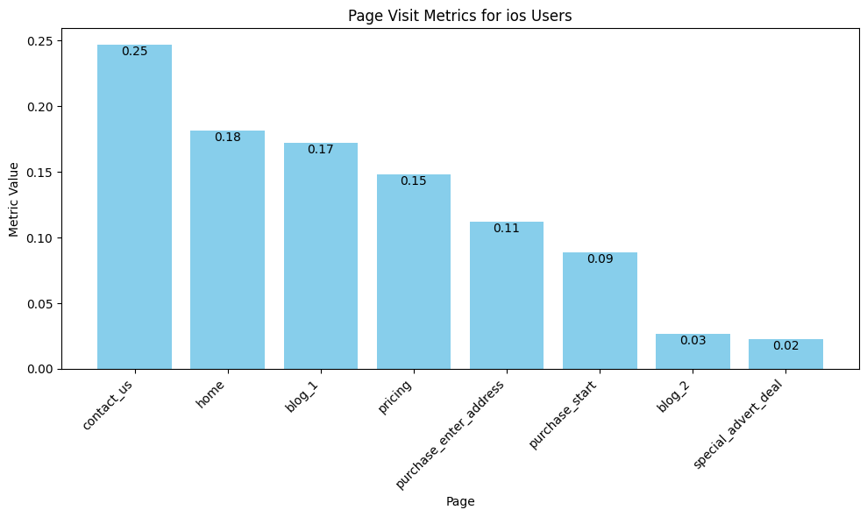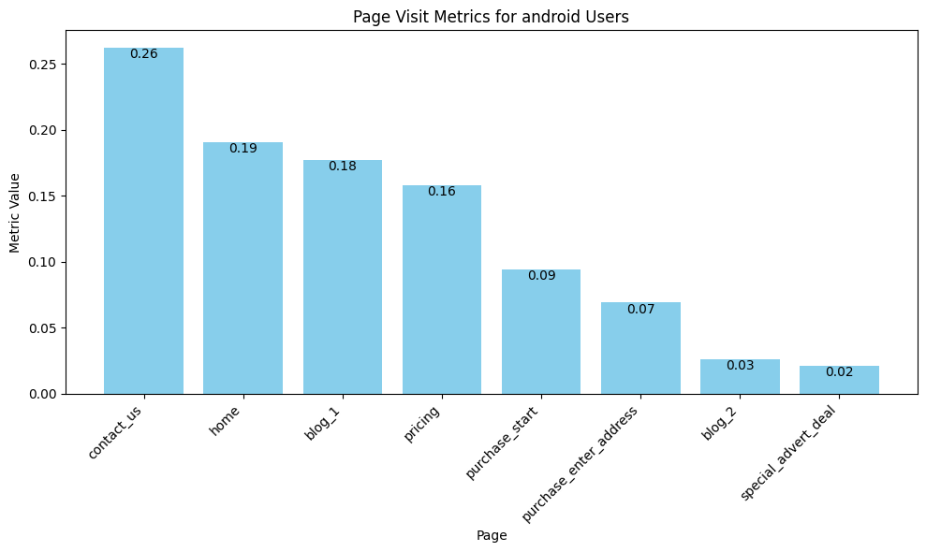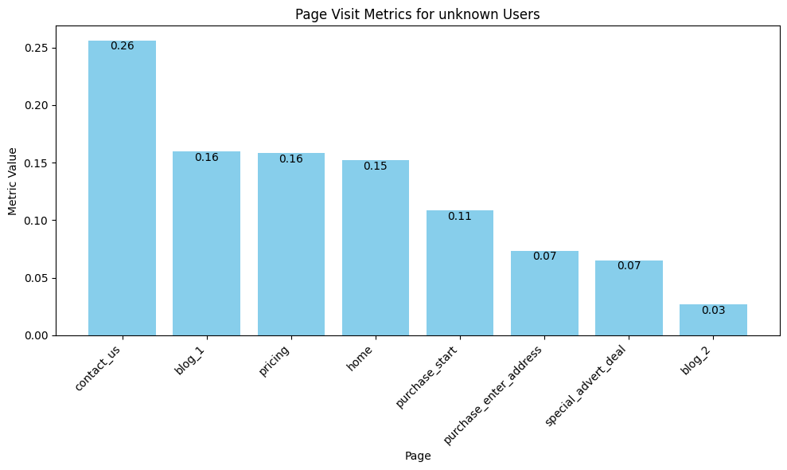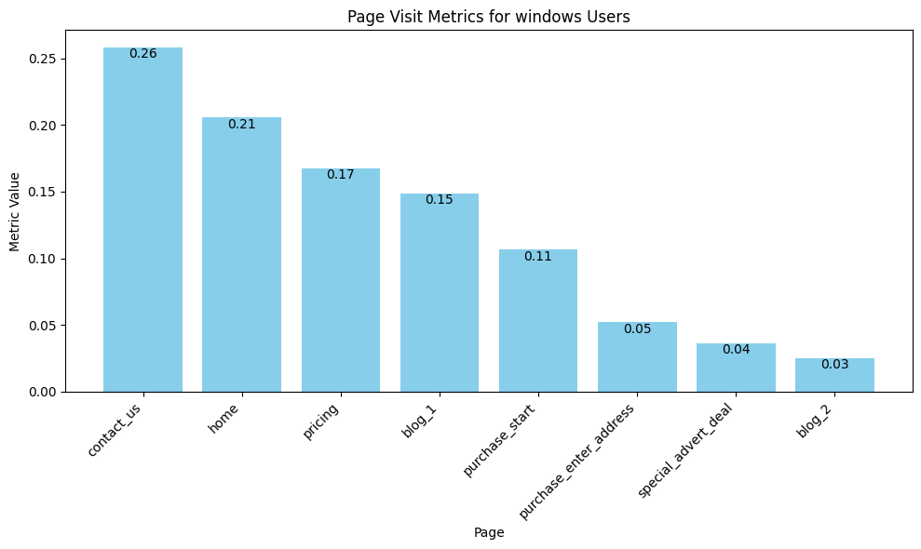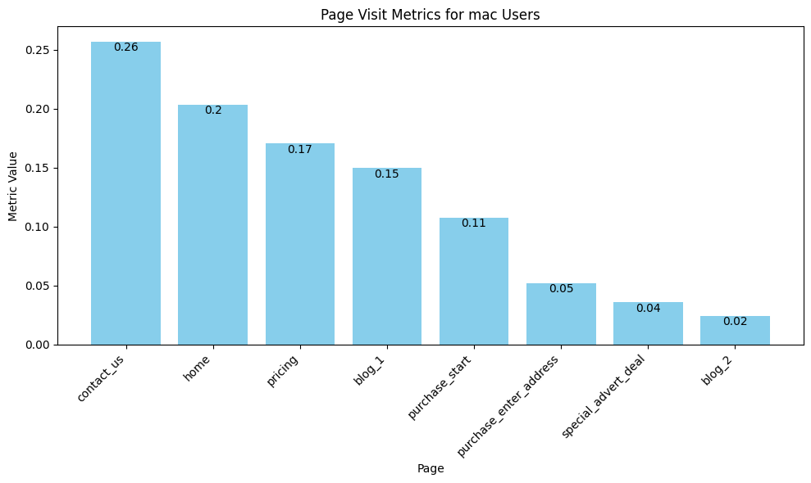**Table 2.** Calculation Results 2

|  |  |  |
| --- | --- | --- |
| **Platforms** | **Dropout rate** | **Struggling stage** |
| android | 39.90% | Blog1 |
| ios | 33.99% | Blog1 |
| windows | 42.44% | Pricing |
| unknown | 34.79% | Blog1 |
| mac | 41.58% | Pricing |

**Figure 1.** Bar Charts of Struggling Stage for Each Platform

### Blog1 VS Blog2

In records of successful purchases, 60.41% visited "blog_1", while 48.50% visited "blog_2". The writing style of Blog1 is more commendable.

## Conclusion

Through 3 topics above, we can conclude that optimizing digital strategies through web and social analytics offers businesses enhanced recruitment, targeted influencer engagement, and effective advertising, but requires nuanced, strategic implementation to navigate technological and social complexities effectively.

## References

Udemans, C. (2019) 'Former Zhaopin employees allegedly leaked 160,000 resumes to sell online', TechNode, 11 July. Available at: https://technode.com/2019/07/11/former-zhaopin-employees-allegedly-leaked-160000-resumes-to-sell-online/ (Accessed: 14 February 2024).